Michal kamara 032813909
Liran klein 031970122
Software testing final project

The bug1 project is a small part of a file system that demonstrate writing from one file to another:

File A
File B
write

To make sure the writing is done properly the programmer inserts two locks: lock the source file and then the lock the target.

The program is multithreaded, a deadlock occur when one thread is writing from file A to B and another thread is writing from B to A. then, the first locks A and the second locks B and there is a deadlock.

File A

First lock
File B

First lock
File B
File A
write
write

So the writing can’t be done and the program “stuck”.

To make sure our program doesn’t “stuck” we use a hashtable that holds the entire locker that we used and free them when not in use.

The program is forced to stop - // System.exit(1); once the first Deadlock happen.

Simply running the program number of times tested the numbers of the “concurrencyParam”.

Our results:
Number of thread | Successes
3 | 90%
7 | 40%
10 | Less then 10%

RaceFinder Analyze

Things we checked:
- In our program, a deadlock occur when one thread writes from A to B and another thread writes from B to A, so we thought that if we noised A and B it will increased the chances of a deadlock.
- Sub sets size of 1, 2, 4, 8 and white noise.
- Type of noise, yield and barrier.
  - For yield we checked the probability range of 90%, 60% 30%.
  - For barrier we checked range of 0-150, 100-150 millisecond and the probability of 90%.
- The effect of the place of the noise (after, before, both).
- Concurrency of little (except from when we noised A and B ).

Results:
- When we noised A and B (and only them) we were surprised to see that the chances of deadlock occurring decreased enormously! There were even lower from the usual result with out adding any noise. We wanted to check this point and added yield manually in the program just before the synchronized and the result were 100% deadlock even in the little concurrency!
Here you can see that when A and B are noised (the only noised one), and the noise is yield (90%) the chances of deadlock bug are very low for all concurrencies:

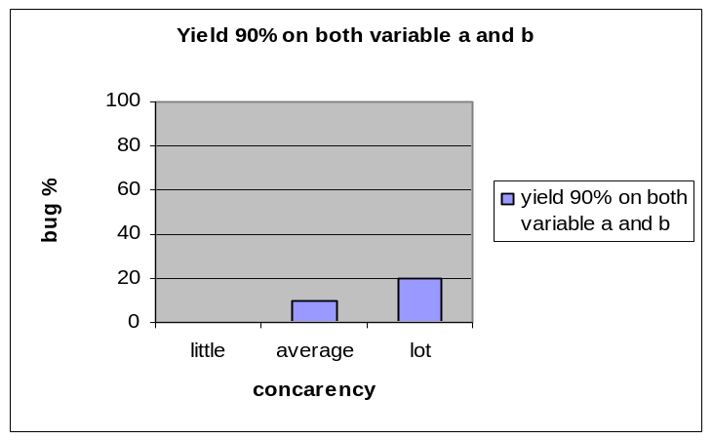
The usual results of the program, with out noise added:
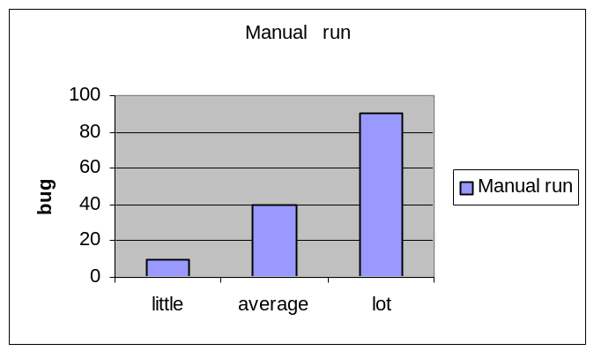

- As we thought, when the noise occurs before the event it is more effective, but the most effective is to add noise before and after.

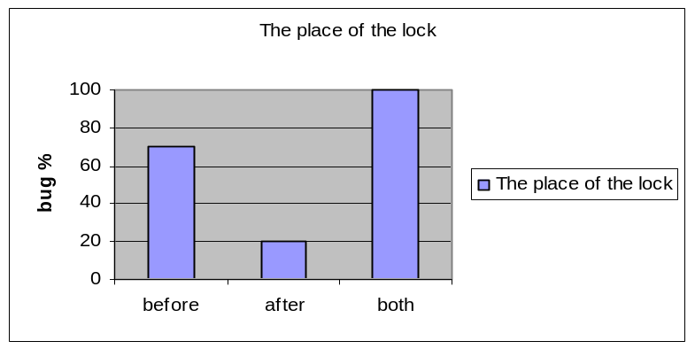
- Regarding the most effective size of sub set we found it is 8, and it seems like a linear correlation between the size of the sub set and the percentage of deadlock found. Thu, sub set of 8 is better then white noise.
- Regarding the probability of the noise, in white noise and sub set size 8, it is a linear correlation. For size of 4 the most affective is probability of 60% and the least effective is 90%. For single variable the most effective is 90% but the least is 60%.

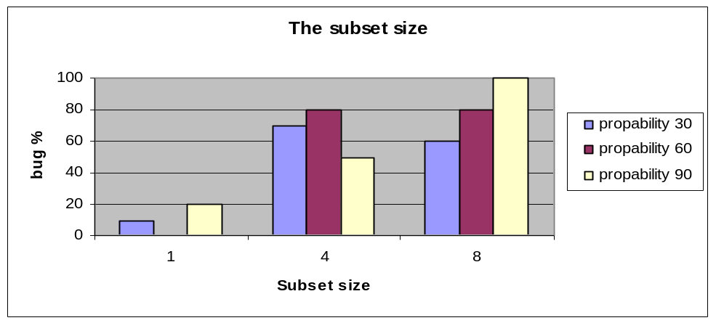
- When we used yield noise we got higher percentage of bug occurring.

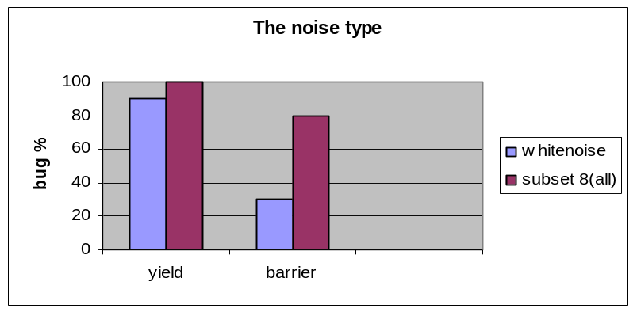

Conclusions

Generally speaking we found that the variation of checks the raceFinder uses is useful and does find more bugs. Almost all our tests were on little concurrency and yet we got high percentages of bugs, due to the type of noise, his probability, his place and the size of the variables group that was tested. The ability to be more accrued and specified the right place to “disturb” the program can save us time in case of number of thread we need to run in order to try and get the same result and that’s the real power of automatic testing.
Our deadlock bug occur in a very specific situation, therefore high percentage of occurring is not a linear correlation to the number of sub set size or its probability. We need a special circle (write(a,b), write (b,a)) and it could be that to much yield is breaking the circle that we expect to happen (for example when we used subset size 4 and the highest percentage of bug were at 60% probability of yield).
But still as expected the highest percentage of bugs occurs in the biggest variables group (8) and for the highest probability of noise.
As mentioned before, we had a special check for variables A and B, and the result were quite surprising, our conclusion by that data is that for this specific bug, the algorithm of the yield noise that is add to specific variables is not good.

